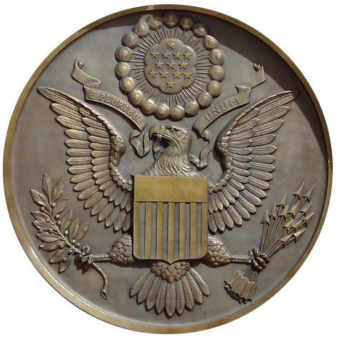
The Secretary of State is the official custodian of the great seal of the United States. It is only attached (affixed) to certain documents, such as foreign treaties and presidential proclamations. The Great Seal is kept in a mahogany cabinet and displayed in the Exhibit Hall of the Department of State in Washington, D.C.
The United States seal has a rich history beginning with our founding fathers in 1776 when the first Continental Congress resolved that Dr. Franklin, Mr. Jefferson, and J. Adams "bring in a device for a seal for the United States of America." Both sides of the Great Seal can be seen on the back of a U.S. one-dollar bill.
On July 4, 1776, Benjamin Franklin, John Adams, and Thomas Jefferson were given the task of creating a seal for the 13 United States of America. The delegates of the Constitutional Convention believed an emblem and national coat of arms would be evidence of an independent nation and a free people with high aspirations and grand hopes for the future.
The Great Seal was finalized and approved six years later on June 20, 1782. The symbols on the seal reflect the beliefs and values that the Founding Fathers wanted to pass on to their descendants.
Eagle: In the center of the seal is a bald eagle (our national bird). The eagle holds a scroll in its beak inscribed with our original national motto: "E Pluribus Unum," which is Latin for "one from many" or "one from many parts" (one nation created from 13 colonies). The eagle grasps an olive branch in its right talon and a bundle of thirteen arrows in its left. The olive branch and arrows are symbols for the power of peace and war.
Shield: A shield with thirteen red and white stripes covers the eagle's breast. The shield is supported solely by the American eagle as a symbol that Americans rely on their own virtue.
The red and white stripes of the shield represent the states united under and supporting the blue, which represents the President and Congress. The color white is a symbol of purity and innocence; red represents hardiness and valor; and blue signifies vigilance, perseverance, and justice.
Cloud: Above the eagle's head is a cloud surrounding a blue field containing thirteen stars which form a constellation. The constellation denotes that a new State is taking its place among other nations.

